**Cozy Haven Stay – Hotel Booking System**

* **Sudharsana Inbakumar**

**Creation of New Connection**

**Step 1: Creating the new User (Schema) in SQL*Plus (Backend CMD)**

**1.** **Connecting to FREEPDB1 as system:**

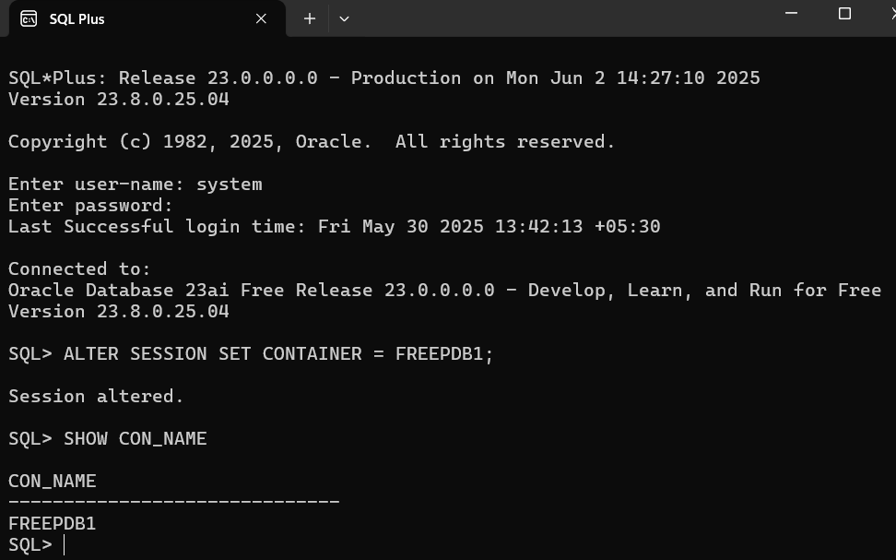

**2.** **Creating the COZY_HAVEN_STAY_APP user and granting privileges:**

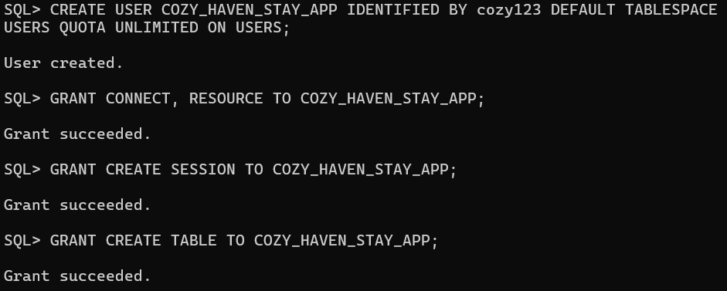

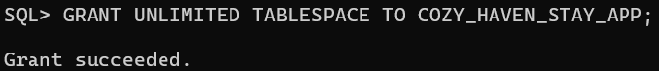

**Step 2: Creating the New Connection in SQL Developer**

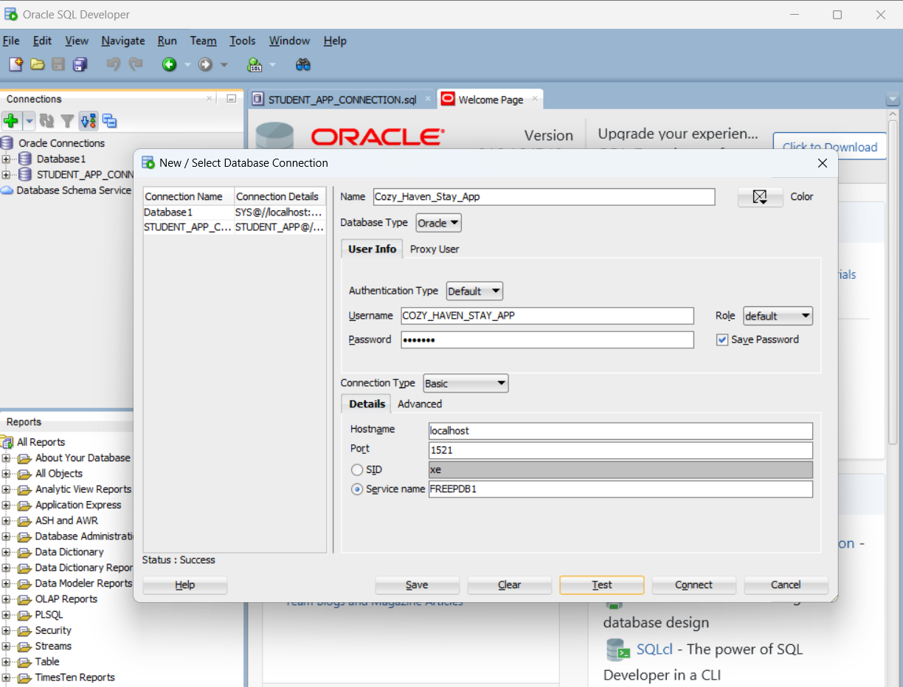

**Successfully created a new connection**

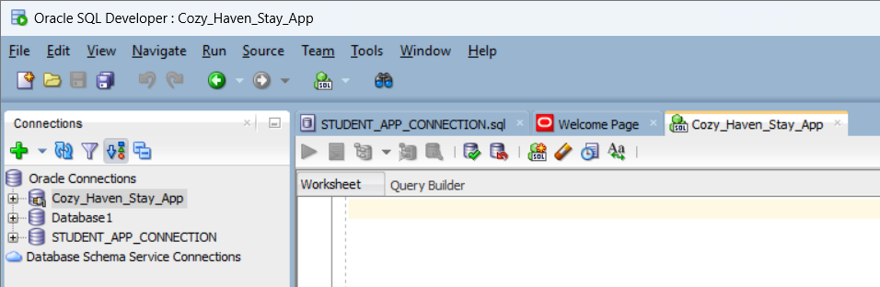

**Database Design:**

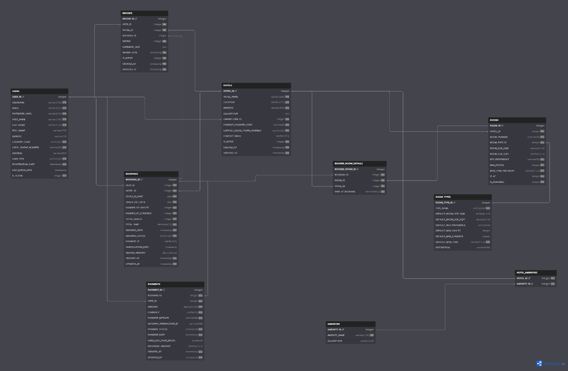

**Creation of Tables:**

1.Users

2.Hotels

3.Rooms

4.Room_Types

5.Bookings

6.Booked_Rooms_Details

7.Amenities

8.Hotel_Amenities

9.Payments

10.Reviews

**Relationship Mapping:**

|  |  |  |  |  |
| --- | --- | --- | --- | --- |
| Entity 1 | Relationship | Entity 2 | Cardinality | Significance |
| USERS | ***OWNS*** | **HOTELS** | **1:M** | One User (HOTEL_OWNER) can own multiple Hotels. |
| HOTELS | ***CONTAINS*** | **ROOMS** | **1:M** | One Hotel can have many Rooms of various types. |
| ROOM_TYPES | ***CATEGORIZES*** | **ROOMS** | **1:M** | One Room Type (e.g., "Deluxe") can categorize many individual Rooms. |
| USERS | ***BOOKS*** | **BOOKINGS** | **1:M** | One User (GUEST) can make multiple Bookings. |
| HOTELS | ***RECEIVES*** | **BOOKINGS** | **1:M** | One Hotel can receive many Bookings. |
| BOOKINGS | ***INCLUDES*** | **BOOKED_ROOM_DETAILS** | **1:M** | One Booking can include details for multiple Booked Room Details (if multiple rooms booked). |
| ROOMS | ***INCLUDED_IN*** | **BOOKED_ROOM_DETAILS** | **1:M** | One Room can be included in many Booked Room Details (over time if booked multiple times). |
| HOTELS | ***LINKED_TO*** | **BOOKED_ROOM_DETAILS** | **1:M** | One Hotel has many Booked Room Details associated with its rooms. |
| HOTELS | ***OFFERS*** | **AMENITIES** | **M:N** | A Hotel can offer many Amenities, and an Amenity can be offered by many Hotels (via junction). |
| BOOKINGS | ***HAS*** | **PAYMENTS** | **1:M** | One Booking can have multiple Payments (e.g., initial payment, refunds). |
| USERS | ***INITIATES*** | **PAYMENTS** | **1:M** | One User can initiate multiple Payments. |
| USERS | ***WRITES*** | **REVIEWS** | **1:M** | One User can write multiple Reviews. |
| HOTELS | ***RECEIVES*** | **REVIEWS** | **1:M** | One Hotel can receive many Reviews. |
| BOOKINGS | ***ASSOCIATED_WITH*** | **REVIEWS** | **1:0..1** | One Booking can be linked to at most one Review, but a Review might not always be linked. |

**Creation of Tables:**

**1.Users**

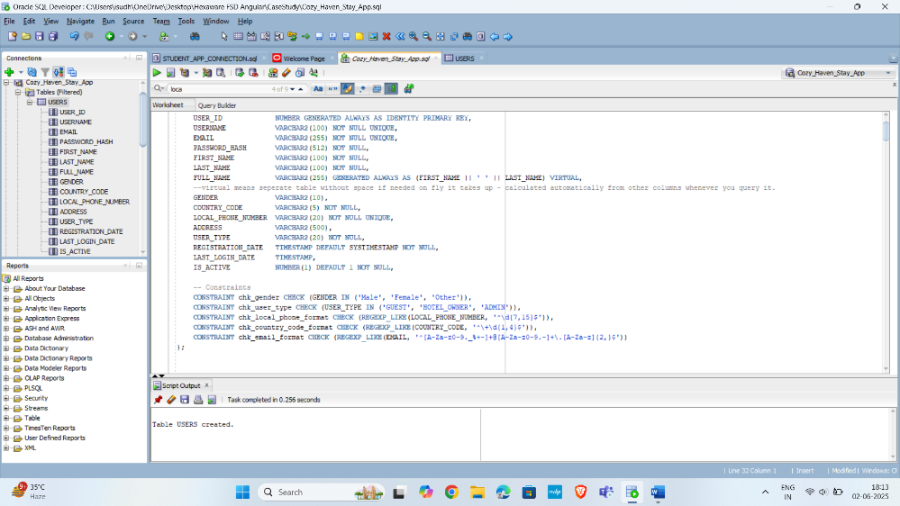

**2.Hotels**

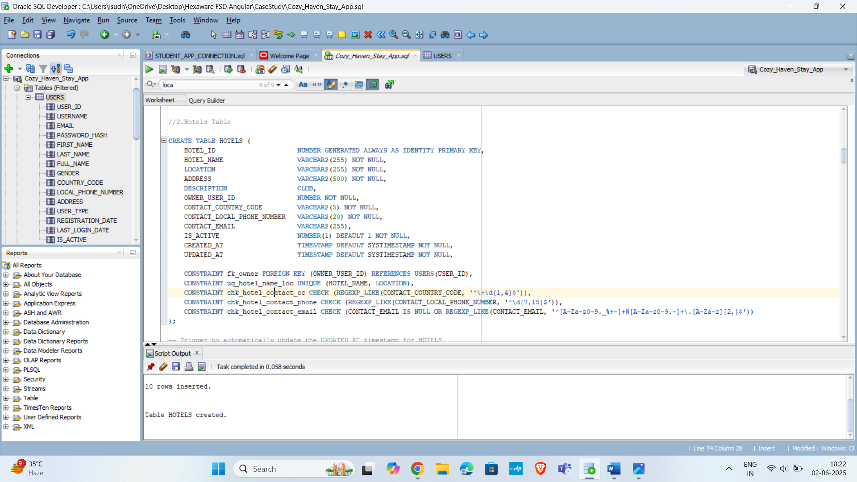

**3.Rooms**

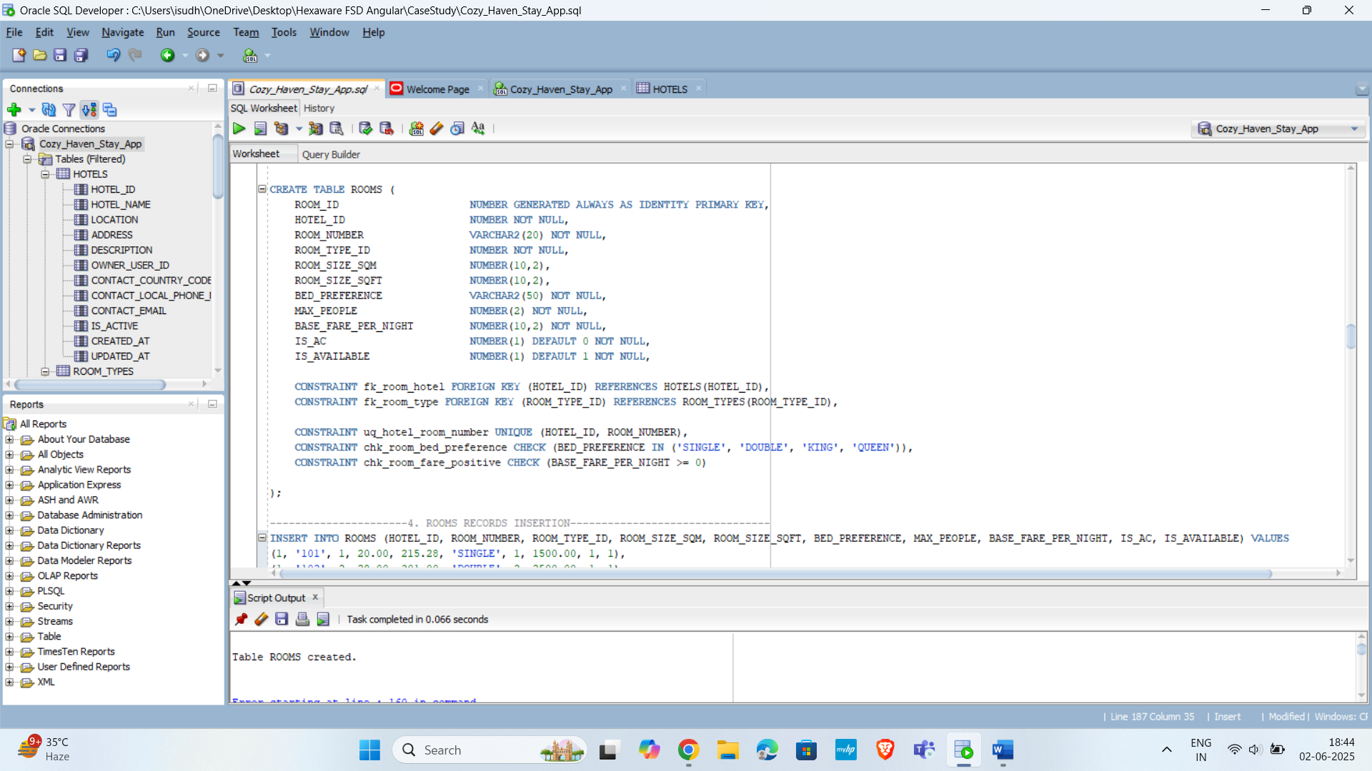

**4.Room_Types**

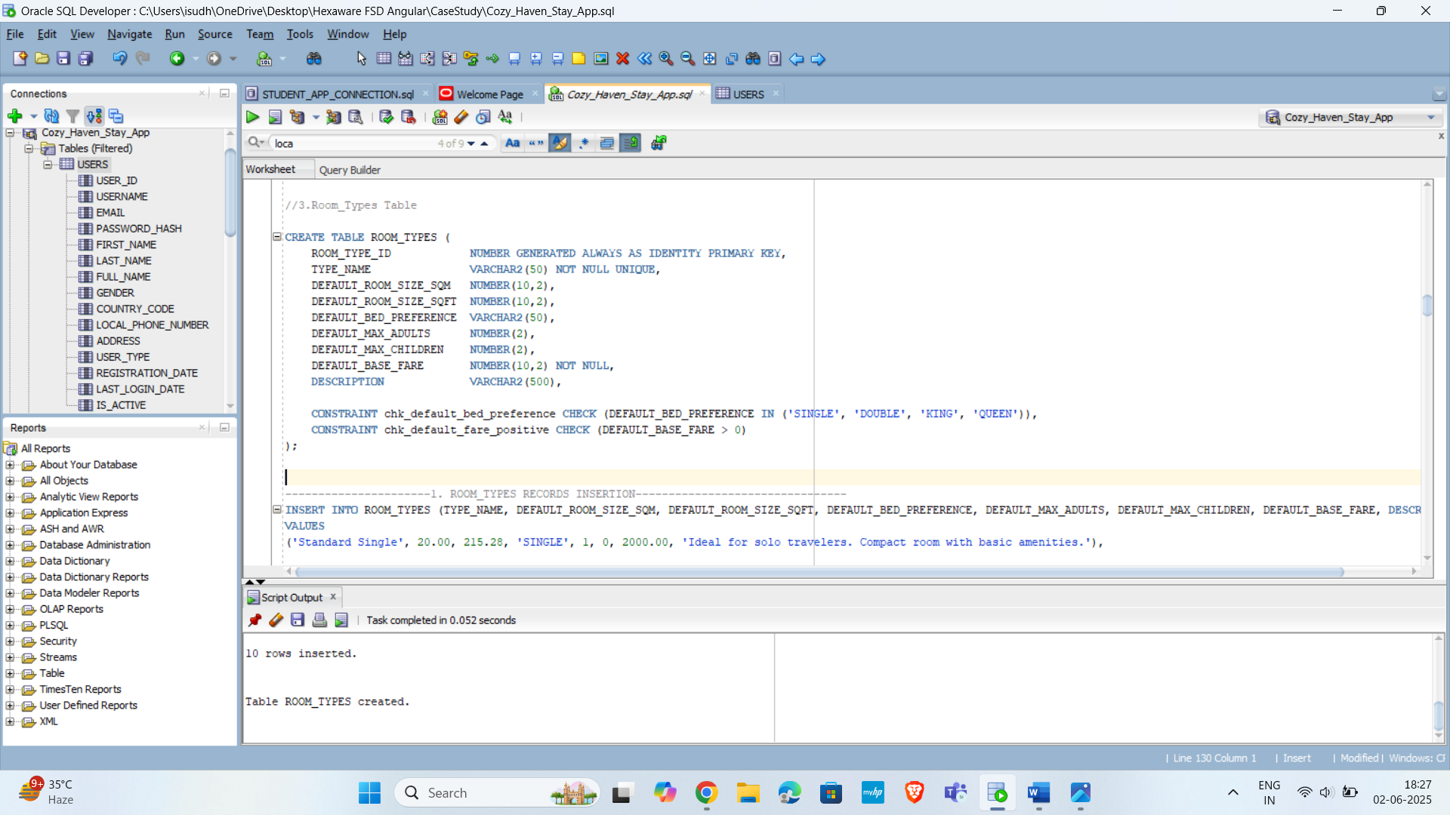

**5.Bookings**

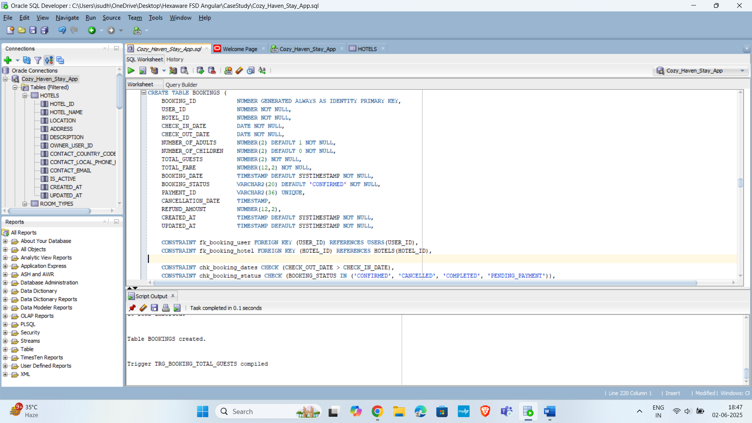

**6.Booked_Rooms_Details**

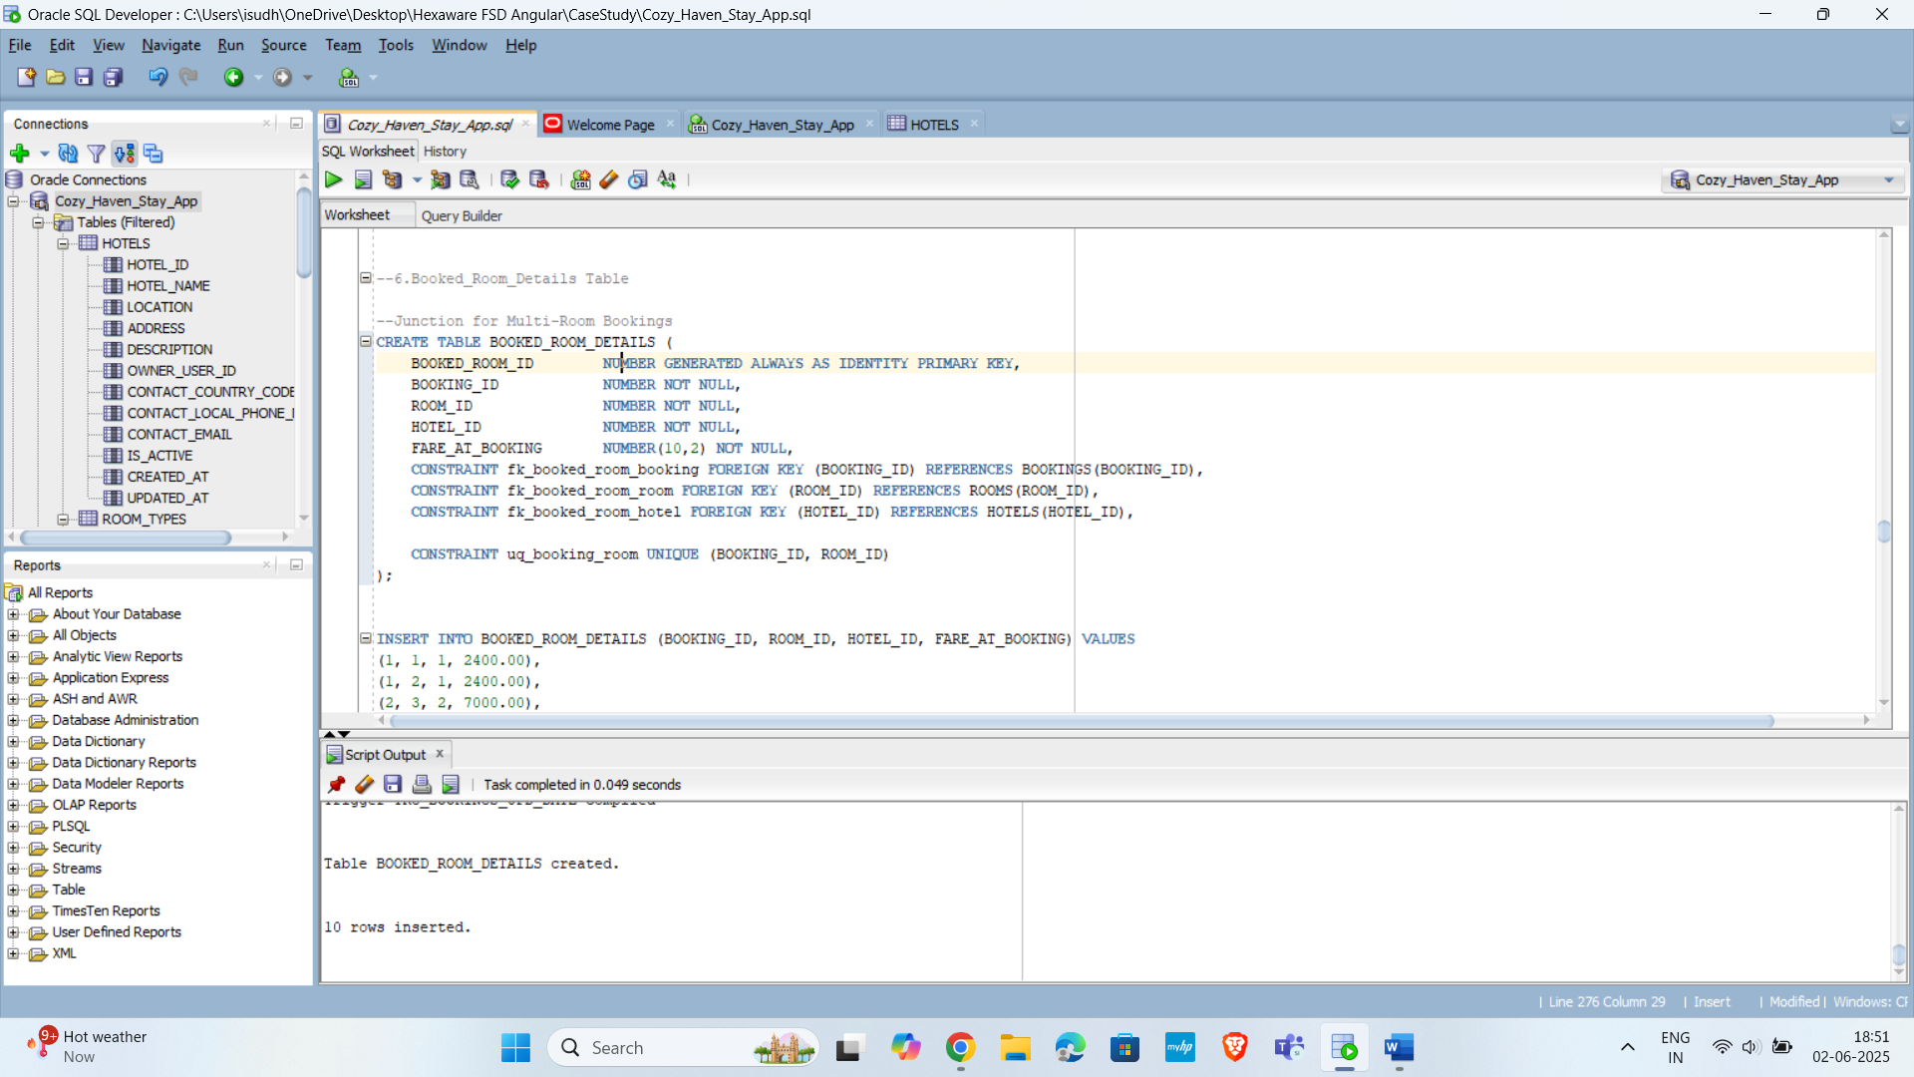

**7.Amenities**

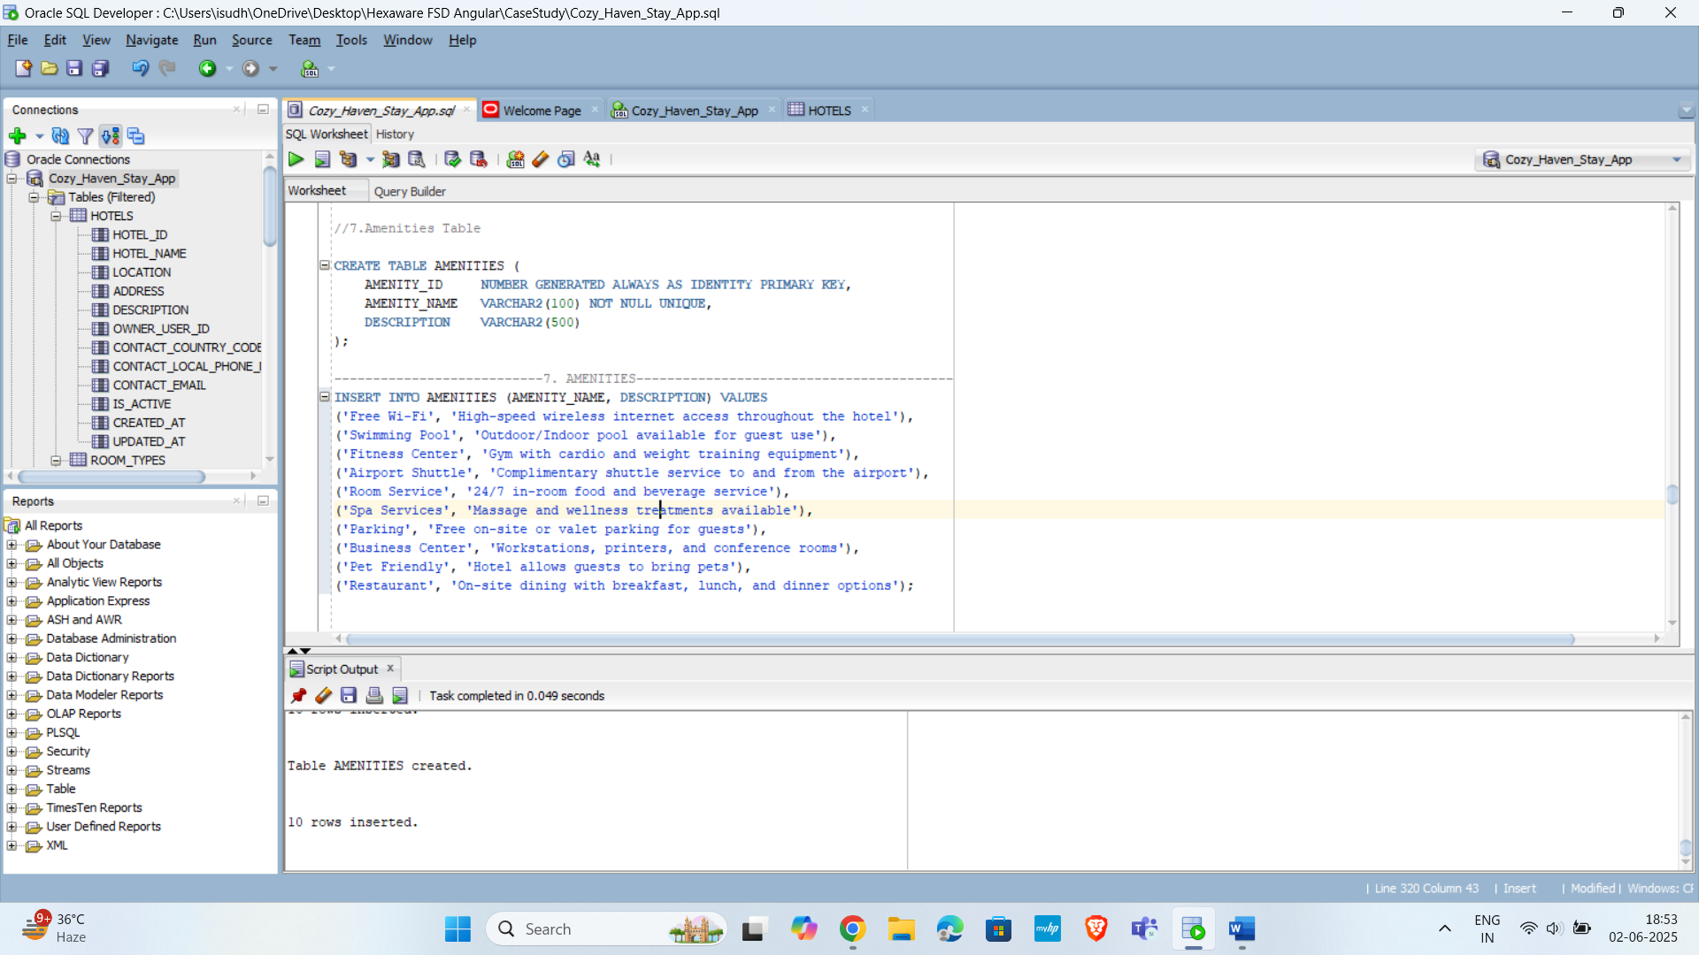

**8.Hotel_Amenities**

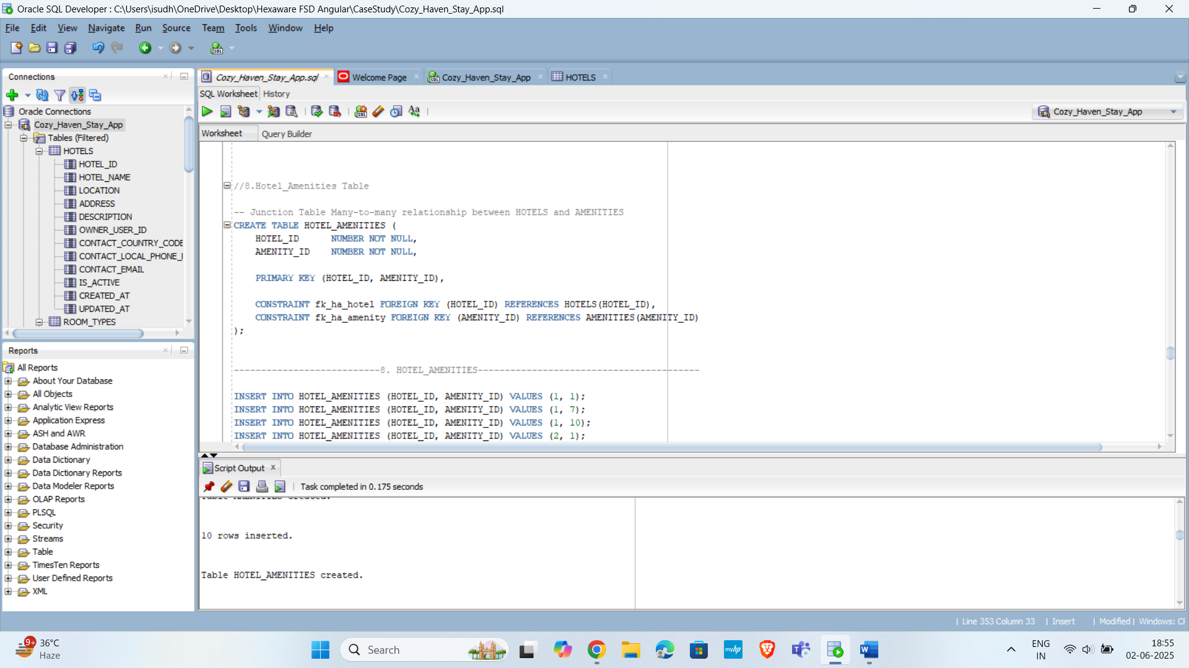

**9.Payments**

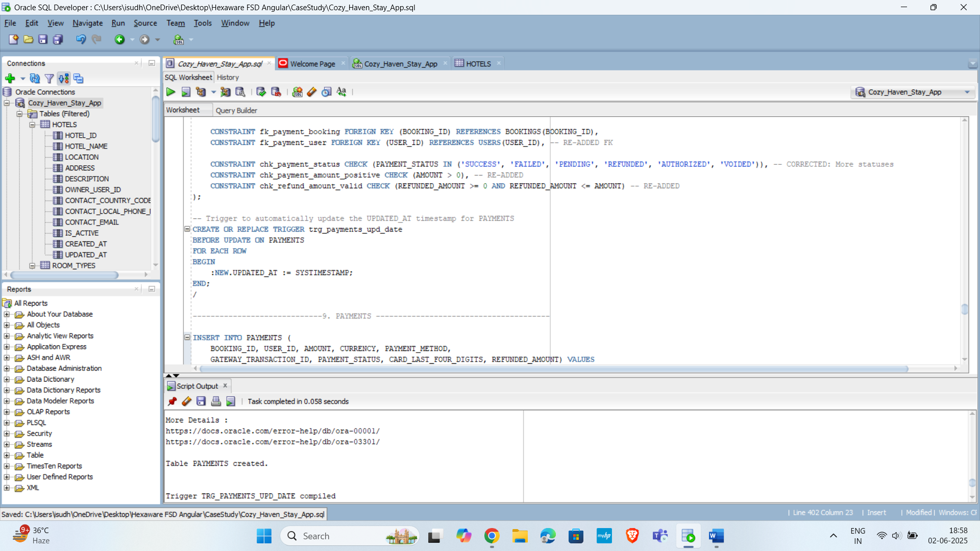

**10.Reviews**

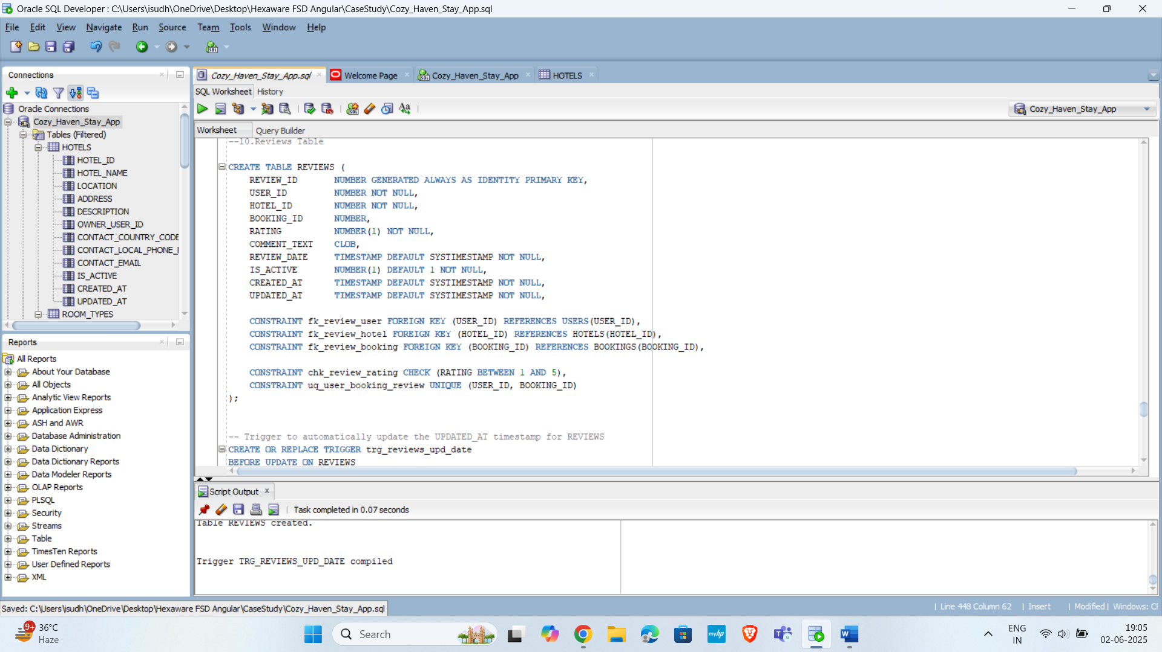

**Insertion of records in Tables:**

**1.Users**

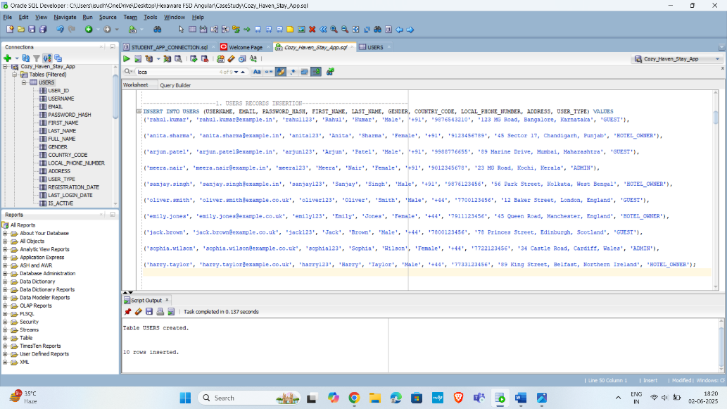

**2.Hotels**

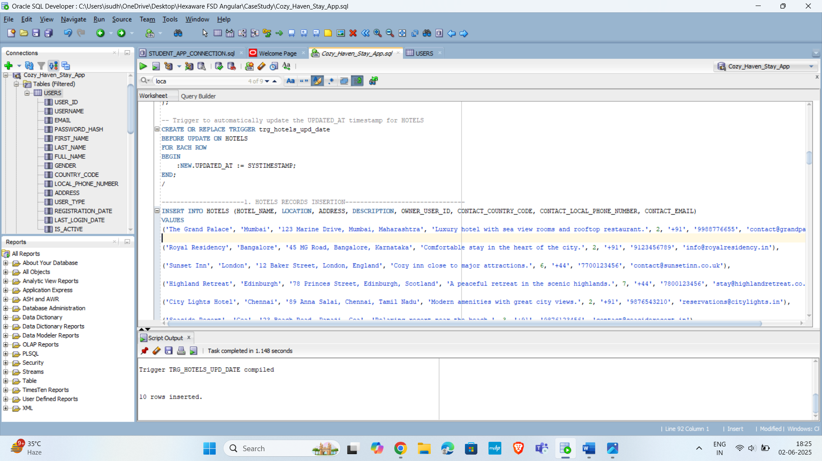

**3.Rooms**

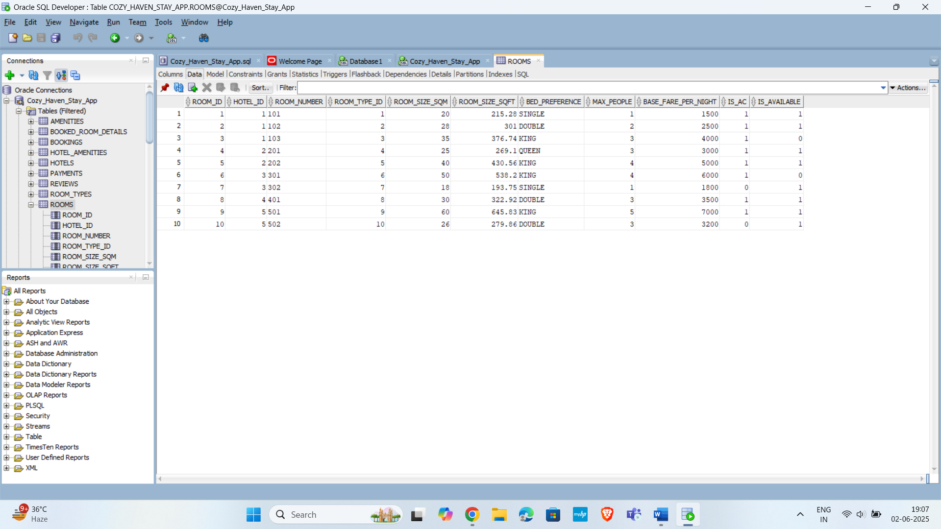

**4.Room_Types**

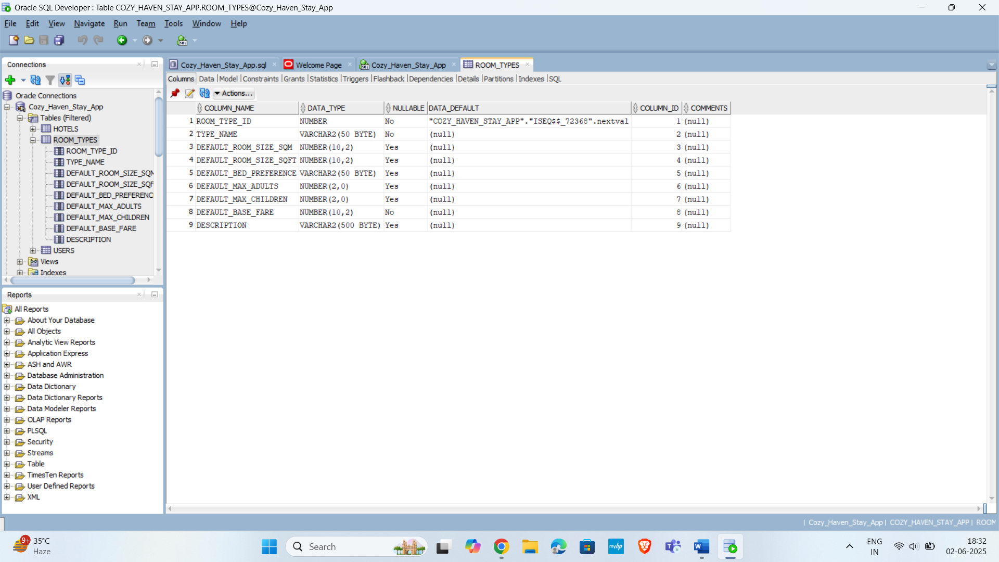

**5.Bookings**

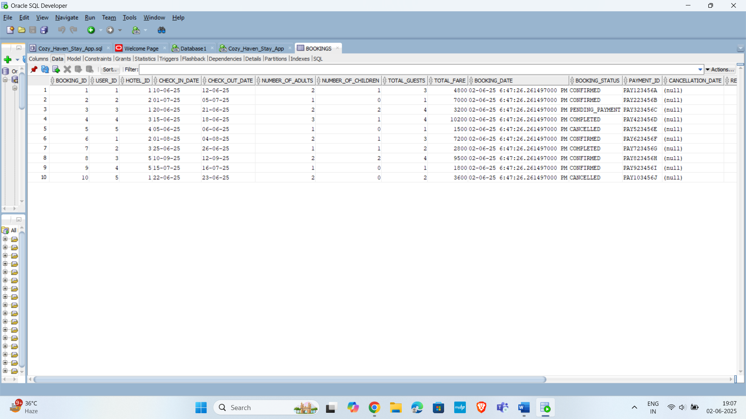

**6.Booked_Rooms_Details**

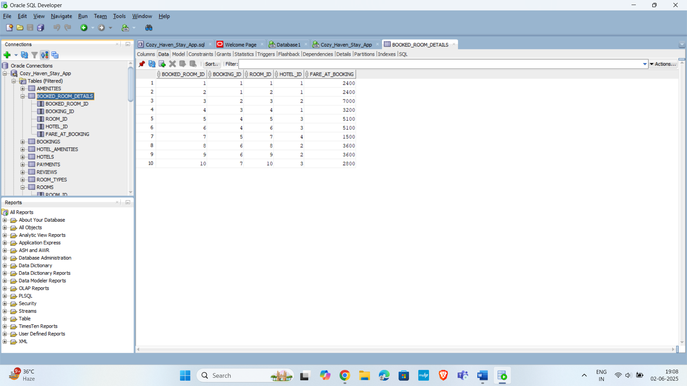

**7.Amenities**

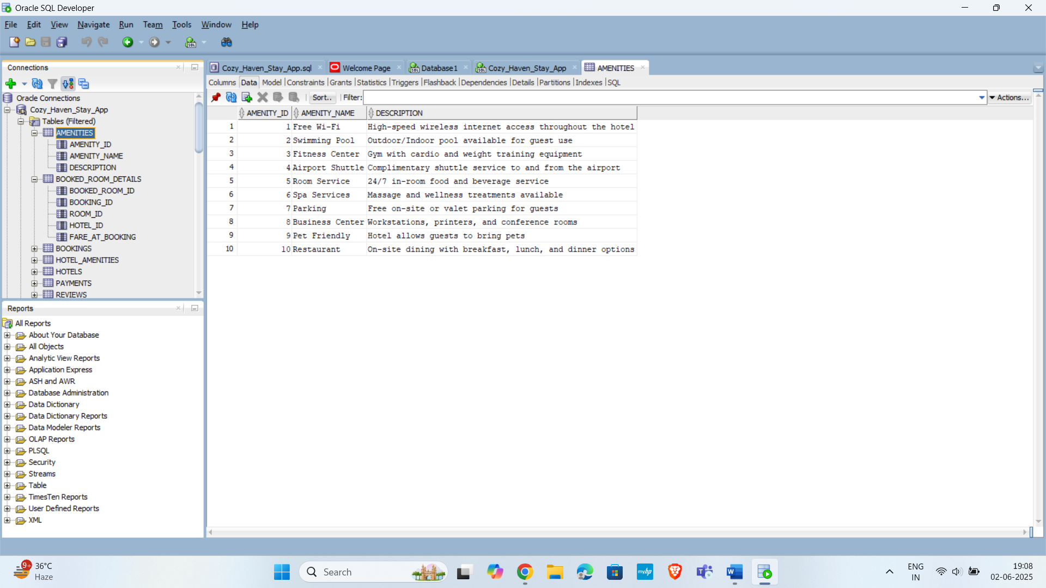

**8.Hotel_Amenities**

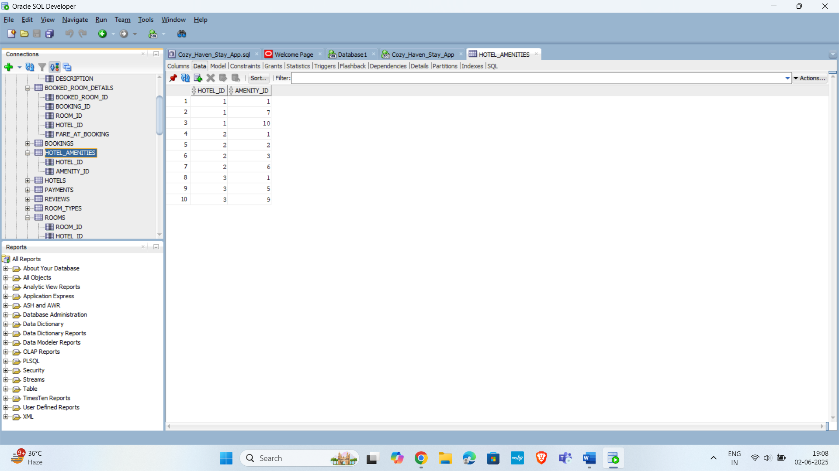

**9.Payments**

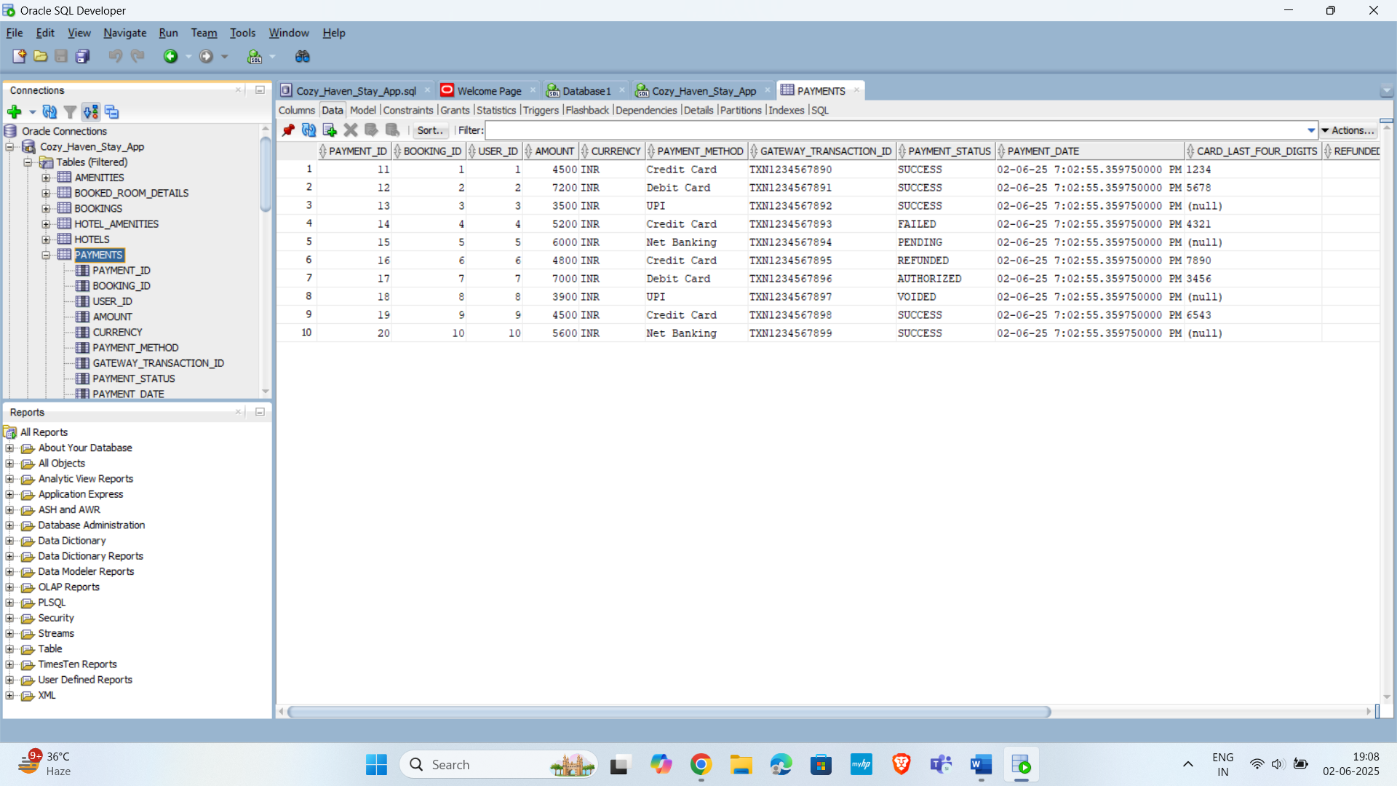

**10.Reviews**

